Order Of Service

Singing: Psalm 8—CW page 67

Reading: Psalm 68:19-35

Opening Hymn: TLH 127

Reading: Acts 8:14-25

Request Hymn: CW Supplement 750

Reading: John 18:1-11

Sermon Hymn: TLH 128

Sermon Text: Daniel 2:36-45

The Meaning of the Dream

Prayer

The Apostles’ Creed, TLH page 12

Holy Communion

The Lord's Prayer

The Blessing

Closing Hymn: TLH 135

* * * * * * * * * * *

Bible Study: Lambs: Cowbird
Sheep: Romans 8:33-39
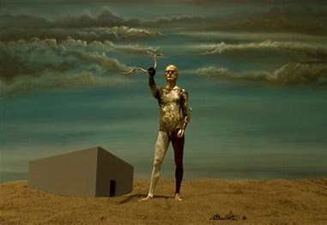
The Mysterious Dream

Water
Of
Life

28 January 2018

W A T E R O F L I F E

Independent Christian Church—Conservative Lutheran Doctrine

Worship Service: 9:30 a.m. Bible Study: 10:45 a.m.

Larry Cooper, Pastor E-Mail address:
111 N. Ridge Road lcooper@wateroflife.cc
Coon Valley, WI 54623 Web Site:
Phone: (608) 452-2105 www.wateroflife.cc

* * * * * * * * * * * * * * * * * * * * * * * * * * *

Sermon Text: Daniel 2:36-45

The Meaning of the Dream

* * * * * * * * * * * * * * * * * * * * * * * * * * *

Daniel 2:36 This is the dream; and we will tell the interpretation thereof before the king.
:37 Thou, O king, art a king of kings: for the God of heaven hath given thee a kingdom, power, and strength, and glory.
:38 And wheresoever the children of men dwell, the beasts of the field and the fowls of the heaven hath he given into thine hand, and hath made thee ruler over them all. Thou art this head of gold.
:39 And after thee shall arise another kingdom inferior to thee, and another third kingdom of brass, which shall bear rule over all the earth.
:40 And the fourth kingdom shall be strong as iron: forasmuch as iron breaketh in pieces and subdueth all things: and as iron that breaketh all these, shall it break in pieces and bruise.
:41 And whereas thou sawest the feet and toes, part of potters' clay, and part of iron, the kingdom shall be divided; but there shall be in it of the strength of the iron, forasmuch as thou sawest the iron mixed with miry clay.
:42 And as the toes of the feet were part of iron, and part of clay, so the kingdom shall be partly strong, and partly broken.
:43 And whereas thou sawest iron mixed with miry clay, they shall mingle themselves with the seed of men: but they shall not cleave one to another, even as iron is not mixed with clay.
:44 And in the days of these kings shall the God of heaven set up a kingdom, which shall never be destroyed: and the kingdom shall not be left to other people, but it shall break in pieces and consume all these kingdoms, and it shall stand for ever.

:45 Forasmuch as thou sawest that the stone was cut out of the mountain without hands, and that it brake in pieces the iron, the brass, the clay, the silver, and the gold; the great God hath made known to the king what shall come to pass hereafter: and the dream is certain, and the interpretation thereof sure.



